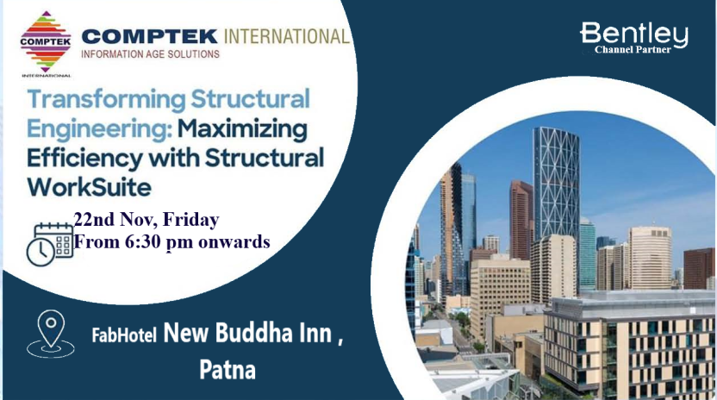

“Transforming Structural Engineering: Maximizing Efficiency with Structural WorkSuite”

Structural WorkSuite is an innovative software solution designed to empower  structural engineers with advanced tools for analysis, design, and detailing. From conceptualization to execution, Structural WorkSuite enhances productivity and facilitates efficient structural design processes, delivering exceptional results in engineering projects.  Discover the secrets to enhancing efficiency in structural engineering with an exclusive seminar focused on leveraging the innovative capabilities of Structural WorkSuite. Join us as we delve into the powerful features of this cutting-edge software and learn how it can optimize your design processes.  In this event, you will:  - Discover the key features and capabilities of Structural WorkSuite that can streamline your design process.  - Learn practical tips and techniques to optimize your workflow and enhance productivity.  - Explore real-world case studies showcasing the efficiency gains achieved with Structural WorkSuite.  Attendees will be able to access in-depth project presentations showcasing challenges, solutions, and outcomes enabled by Structural WorkSuite.  Register Now  Register Now  Venue:  FabHotel New Buddha Inn  Plot No. 14-D, East Boring Canal Road, Boring Rd, opposite Sisodiya Palace, Sri Krishna Puri, Patna, Bihar 800001  Date : 22 Nov 2024 FRIDAY  Time : 6:30 PM ONWARDS    1st Floor, Subodh Granthamala Bluilding, Pustak Path, Ranchi , Jharkhand 834001.  Email: ranchi@compteki.com  Mobile: 9431114356, 9810950651, 7011469109, 06517962067 | PRESENTER    Rajdeep Chatterjee Product Sales Engineer Bentley Systems    Biswatosh Purkayastha Manager, Solution Engineering Bentley Systems    B S Mishra Regional Director  Comptek International    N K Sharma CEO  Comptek International

